**ZOHO APPS**

1. APPLICATION NAME**: ZOHO TODO** VERSION: **1.0.1.8**

**DESCRIPTION OF THE BUG**:

* **TASK ATTACHMENTS** – Upon attempting to attach a file (e.g., image) exceeding the **20 MB** threshold, the application encounters a fatal error, resulting in an unexpected termination (**crash**) due to a potential issue with file handling or memory allocation.

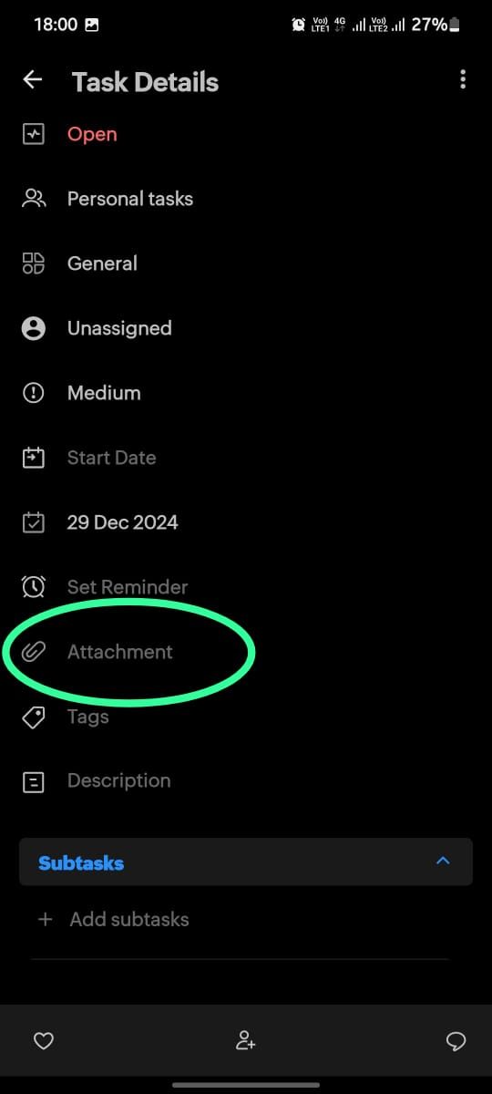 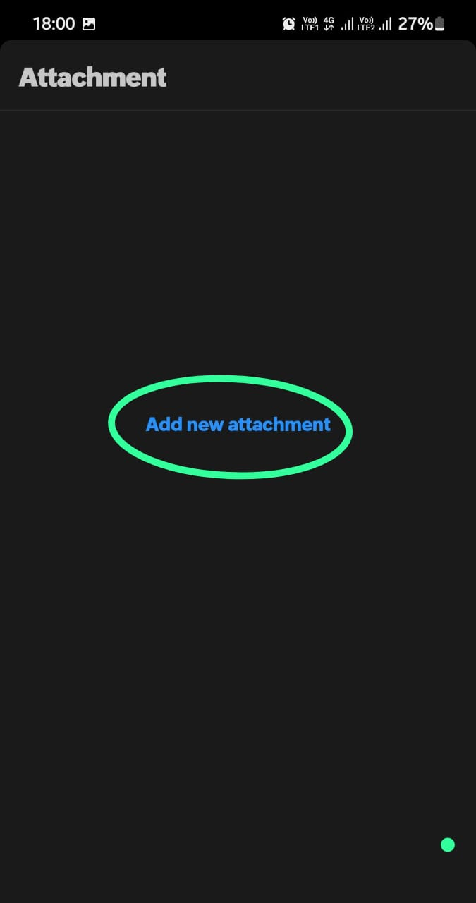

1. APPLICATION NAME**: RECRUIT** VERSION: **4.4.1**
2. **DESCRIPTION OF THE BUG**:

* Even after entering the correct OTP during login, I'm getting a 'Confirm Form Resubmission' error and being prompted to resubmit the form.

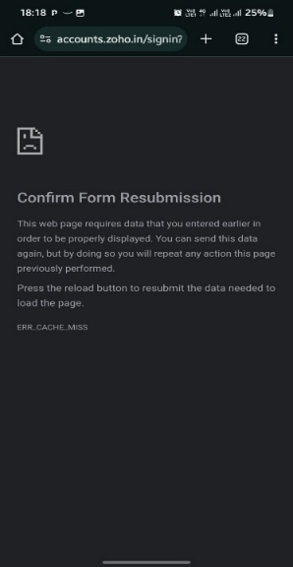

1. **DESCRIPTION OF THE BUG:**

When attempting to access the Recent section within the Recruit application, I am experiencing an Application Crash (Force Close) due to an unhandled exception, resulting in a complete loss of application responsiveness.

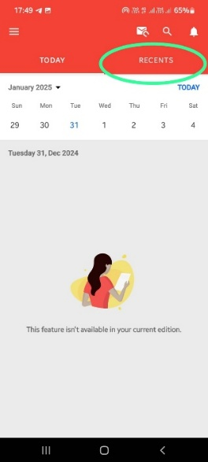 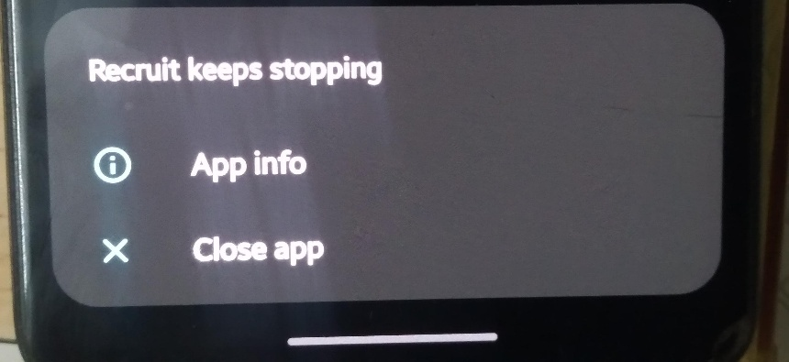

1. APPLICATION NAME**: ZOHO MAIL** VERSION: **2.7.7**

**DESCRIPTION OF THE BUG:**

When attempting to attach a file exceeding 20 MB in Zoho Mail, the application throws an unhandled exception, resulting in a generic error message that lacks descriptive error details, thereby hindering effective error diagnosis and troubleshooting.

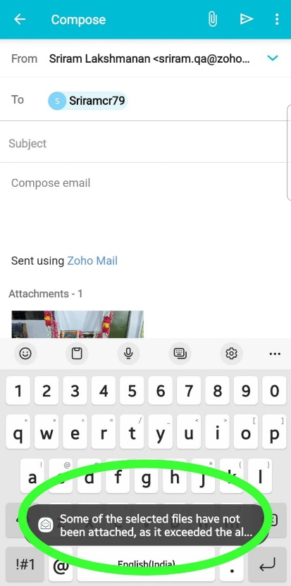

1. APPLICATION NAME**: CALENDER** VERSION: **1.4.1**

**DESCRIPTION OF THE BUG:**

When attempting to authenticate with Google credentials in the Calendar application, the login attempt fails, resulting in an authentication error, potentially due to an issue with OAuth integration or incorrect configuration

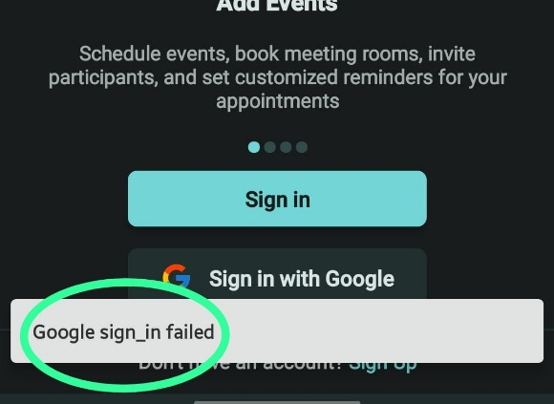

1. APPLICATION NAME**: NOTE BOOK** VERSION: **6.4.1**
2. **DESCRIPTION OF THE BUG:**

**Deleting a note card** in the Notebook application results in the expected behaviour of the deleted item being moved to the Trash folder not being observed, however, the deleted note **remains searchable**, indicating a potential inconsistency in data synchronization or a flaw in the application's data retention and retrieval mechanisms.

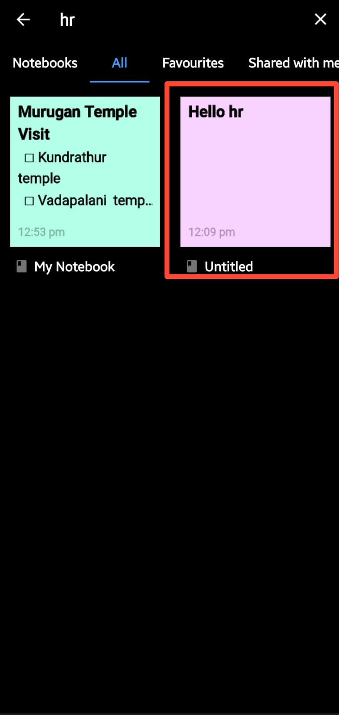 

1. **DESCRIPTION OF THE BUG:**

Attempting to **merge two note cards** results in an unexpected error, with a generic **'Something went wrong**' message being displayed, indicating a potential issue with the application's data merging logic or a backend processing error.

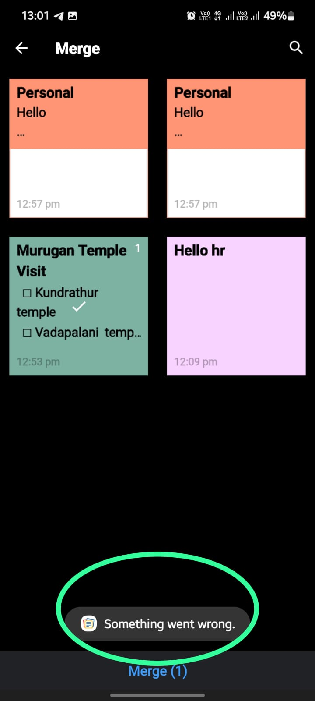

1. **DESCRIPTION OF THE BUG:**

Attempting to **merge a card** into **another note card** triggers an infinite merge loop, resulting in the card being **merged multiple times**, indicating a potential flaw in the application's merge functionality or a logic error in the data processing algorithm.

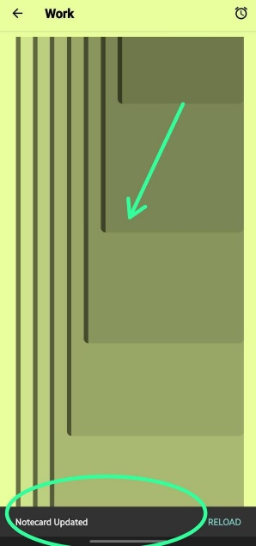

1. WEBSITE NAME**: ZOHO CONNECT**

**DESCRIPTION OF THE BUG:**

Upon attempting to update the **skill set** in the **portal**, the **proficiency** options are limited to only **'Beginner'** and **'None'**, with the skill set rating being restricted to a single-star rating, indicating a potential issue with the application's data validation or a configuration error in the proficiency level settings.

